# Main Variables (Colors, Fonts, etc)

Sass / libs / _vars:

* $palette for colors (-alt suffix for white bg / dark fg)

# Wrappers

**Adds Triangular / Slanted Shape**

Basic Setup:

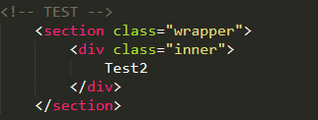

Modifiers:

* alt
  + Flips it horizontally (so the slant goes the other way)
* spotlight
  + Adds bg color: accent
  + stylen (such as style1)
    - changes bg saturation (larger n -> larger saturation)